# The STIL generator is a uvm_subscriber extended component which collects STIL information from drivers through analysis ports and writes them out according to time stamp. To get STIL information, it’s necessary to let drivers take charge of all pad toggle, no any direct pad connection in test bench. Pads are divided into five categories which correspond to jtag_driver, clock_diver, reset_driver, scan_chain_driver and pad_driver. Since clock pads and reset pads connection are usually simple, they get toggle information from configurations directly others are from sequecne_items.

# Each type of pads has a specific driver extends from uvm_driver to interact with them. In Figure1, jtag_driver drives JTAG interface, scan_driver drives scan interface, clock_driver drivers clock pads, reset_driver drivers reset pads and pad_drivers drives other pads.

# Firstly, stil_info_transaction sequence item is defined as Figure 2.

# class stil_info_transaction extends uvm_sequence_item;

# string stil_info;

# string comment_info;

# ……

# endcalss

# stil_info is the pad drive or sample information at a certain time. For example,

# Secondly, add an analysis port, which is an object of uvm_analysis_port class specialized with stil_info_transaction type, in each driver, except for scan_driver. Scan test pattern generation, which are normally generated by ATPG tools, is not the topic of this paper.

# Thirdly, a component named stil_generator, which extends from uvm_subscriber class specialized with stil_info_transaction type, is created. Add correspondent analysis export for each driver in stil_generator. Since uvm_subscriber class has only one built-in analysis export, the `uvm_analysis_imp_decl macro need to be used to declare analysis imp export and its associated write() method for the rest analysis export[2].

# Lastly, connect analysis port and analysis export pair as show in Figure 1 in orange lines.

### Abstract

# The DFT design is becoming more and more complex accompany with the scale increasing of SoC. How to verify DFT logic completely in simulation and supply test patterns to ATE test with highly coverage is important for post-silicon debug and yield increase.

# While verification methodology is evolving, innovating and entering UVM era, DFT verification need to keep in pace to leverage the advantage of UVM, therefore to increase test reusability, extendibility and function coverage and etc.

# This paper presents a general UVM based DFT verification environment, which is usable from modular DFT verification to SoC DFT verification, and it can generate STIL test patterns for ATE test during SoC simulation.

# This paper also presents a method to model hierarchically networked DFT TDR in register abstract level to let test writers focus on test sequences not caring the details of TDR read and write.

### Introduction

# In DFT (Design For Testability) domain, the test patterns running on an ATE (Automatic Test Equipment) can be categorized into two types: scan related and non-scan related. The former can be generated using ATPG (Automatic Test Pattern Generation) tools, while the latter cannot. These non-scan DFT function tests, like other function tests, are normally created by design verification engineers using languages such as System Verilog or C++. However, ATEs need test patterns described by STIL (Standard Test Interface Language) or other test languages.

# To fill the gap, there is usually a dedicated team to transfer function simulation to ATE test environment, or alternatively in-house automation flows are developed to enforce complex rules on test writing and register specification documentation, which are specific for a given environment and difficult to migrate.

# This paper provides a universal and more efficient solution by introducing a UVM (Universal Verification Methodology) based DFT verification environment that naturally generates test patterns in STIL format during simulation and can be plugged into any UVM based environment. This method applies to other formats that ATEs need.

# For ultra-large-scale SoC (System on Chip), IEEE 1149 protocol alone cannot satisfy DFT design requirements, so IEEE 1687 and 1500 protocols are usually adopted to enable modular and hierarchical DFT test access, leading to challenges when writing test sequences at register abstract level, as different protocol TDRs (Test Data Register) are hierarchically located in a network connected via IEEE 1687. To access a TDR one or more levels 1687 SIBs (Segment Insertion Bit) have to be set and the length of DR (Data Register) chain varies with SIB values. The author also comes up with a general way to model complex DFT test access network.

# …point issues need to resolve…

# … review previous work…

# … Important to resolve these issues…

# … What this paper did …

### Proceed of This Paper

# This paper is intended to divide into two parts. The first part is about how to build a UVM based DFT verification environment that can generate STIL test patterns innately. The second part is focus on how to lift DFT TDR to register abstract level. The third part is how to verify the generated STIL pattern is workable. The fourth part is about result discussion and conclusion.

# In the first and second part, each of them will be proceeded as following sections.

# Idea overview.

# Implementation details.

### UVM Based DFT Verification Environment

#### Idea Overview

# The STIL test pattern describes test stimulus using vectors which specify pad toggle and measurement information (called STIL information hereinafter) in a time period.

# A UVM test usually contains one or several sequences; the UVM sequences are finally break down into streams of UVM sequence items (a.k.a transactions) and passes to UVM drivers. UVM drivers are in born the best supplier of STIL information.

# If we restrict any pad drive and sample should be controlled through a UVM driver which enforce no directly pad connection in test bench, collect all STIL information from drivers and then write them out according to the time stamp of STIL information, we can get a complete test vectors of a certain UVM test after simulation finish.

# So we divide pads of a SoC as following groups for DFT functional simulation.

# IEEE 1149.1 compliance on-chip TAP (Test Access Port). Hereinafter it’s simply called JTAG (Joint Test Action Group) interface, which is the most significant interface for DFT design.

# Scan related pads. Hereinafter it’s simply called scan interface, which is a group of pads used as scan control signals and scan channels when a chip is in scan test mode.

# Clock pads. It’s the clocks need toggling in DFT functional simulation. Please see BOZO for more description.

# Reset pads. It’s the asynchronous resets of a chip.

# Other pads. Except for type 1-4 mentioned above, the rest pads are categorized as one type. These pads may need have initial value or be toggled once in a while in simulation.

# In Figure 1, jtag_driver, scan_driver, clock_driver, reset_driver and pad_driver are correspond to above pad group from 1 to 5.The STIL generator collects STIL information from these drivers and writes them out.

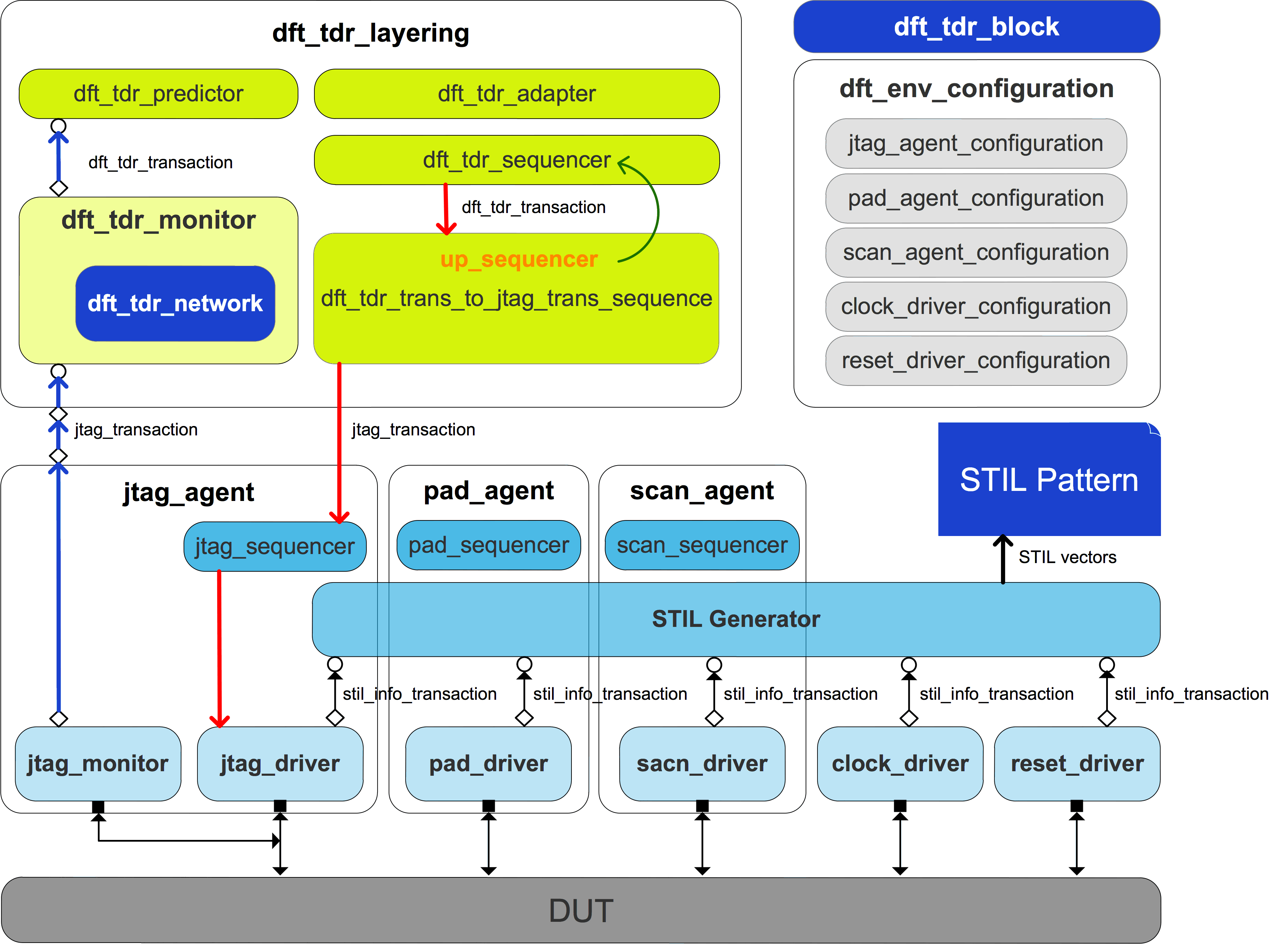

### jtag_agent Implementation

##### jtag_agent_configuration

##### jtag_transaction class

o_ir is a dynamic array to store instruction operation code(a.k.a OPCODE) to be sent to DUT JTAG 1149.1 FSM IR(Instruction Register).

o_dr is a dynamic array to store data to be sent to DUT’s IEEE 1149.1 compliance FSM DR(Data Register).

chk_ir_tdo and chk_dr_tdo are flags to indicate jtag_driver whether to check TDO during shift IR state or shift DR state.

##### jtag_driver class

In jtag_driver, IEEE 1149.1 protocol is implemented. It fetches jtag_transaction sequence items from jtag_sequencer and toggle the JTAG interface.

If the gen_stil_file knob is on, jtag_driver writes

### DFT TDR Abstraction

#### Idea Overview

### STIL Test Pattern Verification

### Conclusion